Model Interpretation and Business Report
Task 2 Report

1. Objective
The goal of this task was to interpret the model selected in Task 1 using feature importance, then translate the technical findings into a short business report covering key drivers, risks, limitations and recommended actions.
A model that predicts well but cannot be explained is hard to trust and hard to act on. This report answers two questions: which factors the model relies on, and which direction each one pushes.

2. Approach
The Random Forest from Task 1 is rebuilt here with the same settings and the same random_state of 42, and the notebook confirms the accuracy and ROC-AUC match Task 1 exactly (0.9458 and 0.9888) before anything is interpreted. That check matters, because interpreting a slightly different model than the one that was evaluated would make the findings meaningless.
Two methods were used together. Random Forest's built-in feature importance answers which features matter. But importance on its own does not say whether high values are good or bad, so the top driver was split into five bands and the real profit rate was measured in each band. That second step is what turns a ranking into something a business can act on.

3. Which Features Matter
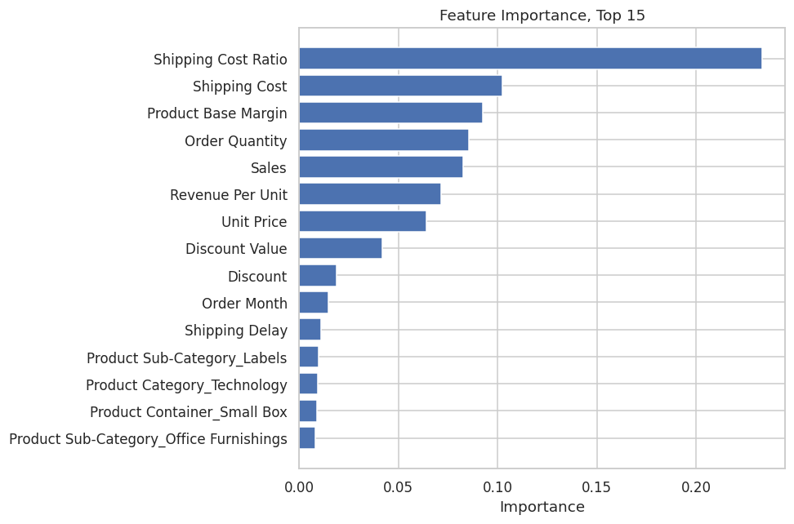
Figure 1: Feature importance, top 15
Feature | Importance
Shipping Cost Ratio | 0.2334
Shipping Cost | 0.1023
Product Base Margin | 0.0925
Order Quantity | 0.0853
Sales | 0.0824
Revenue Per Unit | 0.0716
Unit Price | 0.0641
Discount Value | 0.0419

Shipping Cost Ratio is more than twice as important as the next feature. It is one of the five features created in Task 1, which means the feature engineering did not just improve the score, it produced the single most useful input the model has. Four of the top ten features are engineered ones rather than original columns.

4. How Much Do the New Features Contribute?
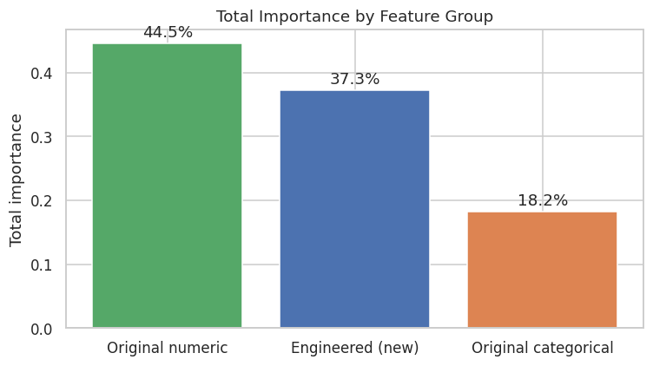
Figure 2: Total importance by feature group
Grouping the importances shows that the five engineered features account for 37.3 percent of the model's decision making, against 44.5 percent for the eleven original numeric columns and 18.2 percent for the seven categorical ones. Five hand-made features carrying over a third of the model is a strong result for one afternoon of feature engineering.

5. Which Direction Does the Top Driver Push?
Feature importance says Shipping Cost Ratio matters, but not whether a high ratio is good or bad. Splitting it into five equal-sized bands and measuring the actual profit rate in each answers that directly.
Shipping Cost Ratio band | Orders | Profit rate | Average profit
Very Low | 1,680 | 90.4% | 1,106.74
Low | 1,680 | 78.3% | 166.29
Medium | 1,679 | 49.1% | -103.45
High | 1,680 | 20.6% | -148.11
Very High | 1,680 | 7.7% | -115.72

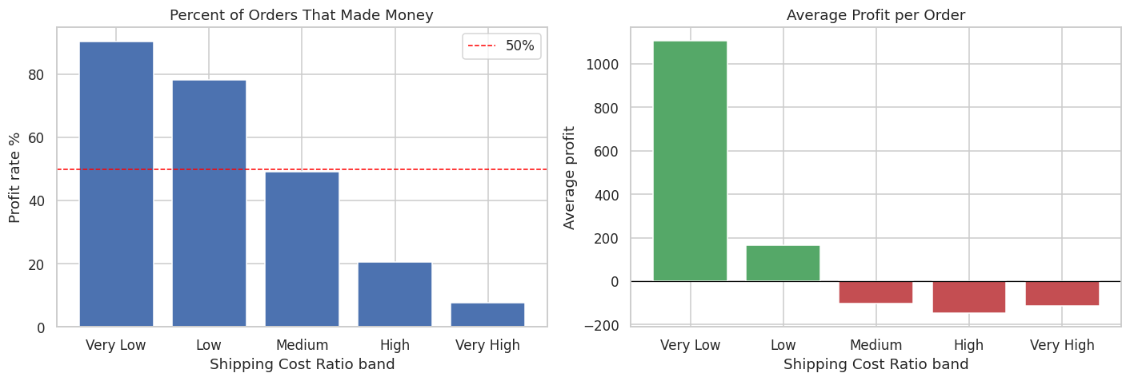
Figure 3: Profit rate and average profit across shipping ratio bands
The direction is clear and the effect is very large. Where shipping takes a small share of the sale, 90 percent of orders make money. Where it takes a large share, only 8 percent do. This is the strongest single pattern in the entire dataset.

6. Where the Losses Sit
The model explains what drives profit. A manager also needs to know which parts of the business are worst affected.
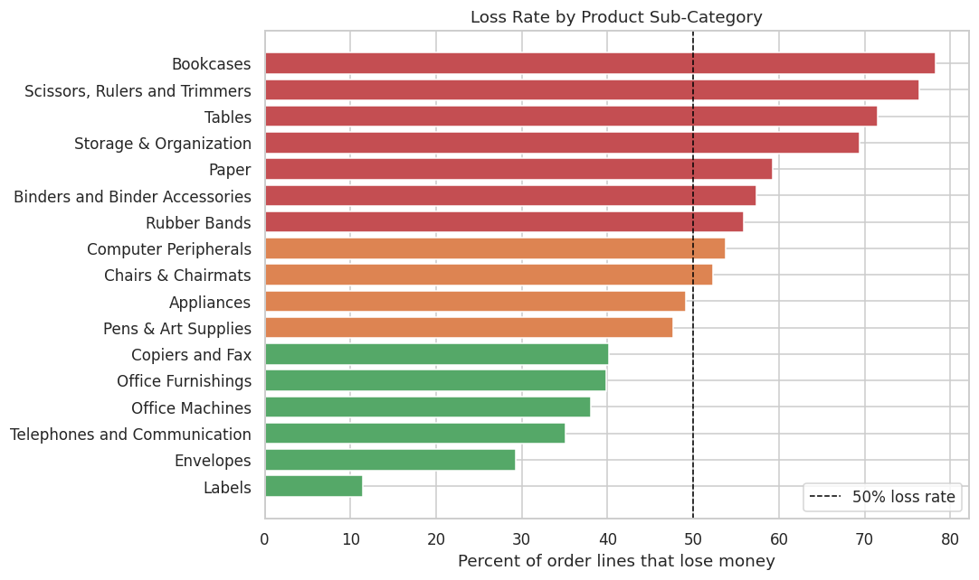
Figure 4: Loss rate by product sub-category
Sub-Category | Orders | Loss rate | Total profit
Bookcases | 189 | 78.3% | -33,582
Scissors, Rulers and Trimmers | 144 | 76.4% | -7,799
Tables | 361 | 71.5% | -99,062
Storage & Organization | 546 | 69.4% | 6,664
Paper | 1,225 | 59.3% | 45,263

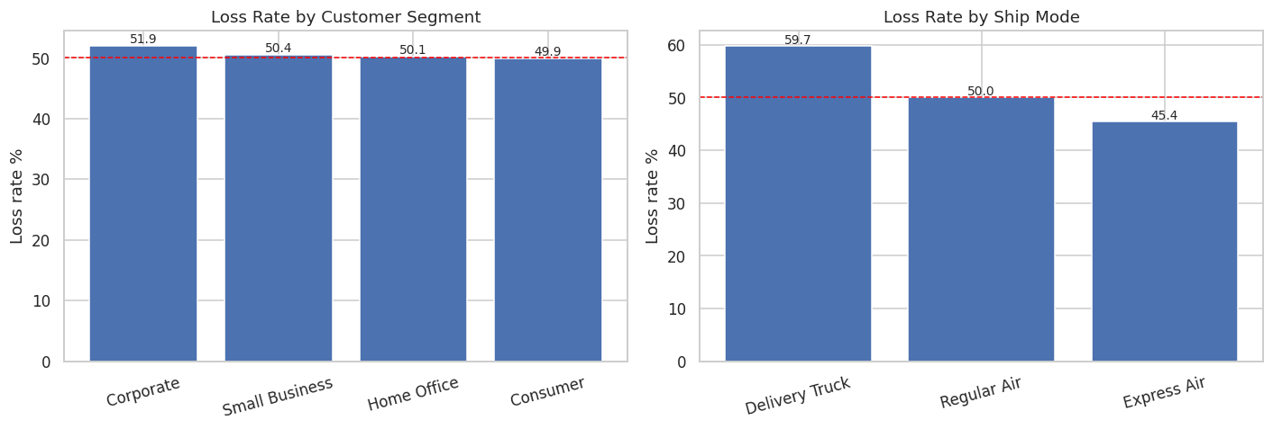
Figure 5: Loss rate by customer segment and by ship mode

7. Checking the Interpretation
A simple way to test whether the importance ranking is real: shuffle a feature so its values become meaningless, then see how much worse the model gets. If Shipping Cost Ratio really is the main driver, scrambling it should hurt a lot, while scrambling a low-importance feature should barely matter.
Condition | ROC-AUC | Damage
Normal | 0.9888 | -
After shuffling Shipping Cost Ratio | 0.8716 | 0.1172
After shuffling Order Month (weak feature) | 0.9887 | 0.0001

Scrambling the top feature costs 0.1172 of ROC-AUC, while scrambling a weak feature costs 0.0001. The importance ranking is describing something real rather than being an artifact of how the chart was drawn.
8. Business Report
Written for a non-technical reader.

What was built
A model that looks at an order and predicts whether it will make money or lose money, before the order is completed. It gets this right about 95 times out of 100 on orders it has never seen before.

Why it matters
Just over half of all order lines currently lose money. Sales figures look healthy while profit does not, and the gap between the two is the main problem in this business.

Key drivers
- Shipping cost as a share of the sale. This is by far the biggest driver. Orders where shipping takes a small share of the sale value make money 90 percent of the time. Orders where shipping takes a large share make money only 8 percent of the time.
- Revenue per unit. Cheap items are riskier than expensive ones, because the shipping and handling cost does not shrink in proportion to the price.
- Product base margin and product sub-category. Profitability is very uneven across the catalogue. Some sub-categories lose money as a general rule, not by accident.
- Discount value. The actual money given away matters more than the discount percentage.

Risks
- The data has no cost-of-goods column. The model estimates profitability from price, discount and shipping. If purchase costs change, its judgement will be wrong without any warning.
- The model makes mistakes in both directions. On the test set it approved 32 orders that actually lost money, and flagged 59 profitable orders as risky. Used as an automatic reject rule, it would turn away good business.
- It is based on past data. A change in pricing or shipping policy would make parts of it out of date.
- It shows patterns, not causes. The model shows that loss-making orders tend to have high shipping ratios. It does not prove that reducing shipping cost would make those particular orders profitable.

Limitations
- No cost-of-goods data, which limits how accurate any model can be here.
- Predictions are made per order line, not per customer, so an order that loses money but wins a valuable long-term customer looks like a plain failure.
- The model was not tuned, so it is probably not at its best.
- Customer history is not used at all.

Recommended actions
- Look at shipping costs on cheap, bulky products first. This is the strongest driver in the model and it is something the business can directly control, through minimum order sizes, shipping charges, or better carrier rates.
- Review the loss-making sub-categories, starting with Tables. Tables alone loses 99,062, and over 70 percent of its order lines are unprofitable. This action needs no model, just a decision to act on the numbers.
- Check the margin before approving a discount. Discount value shows up as a driver, and discounts are currently applied without reference to the margin underneath them.
- Use the model as a warning, not as an automatic reject. Flag risky orders for a person to review. Because the model makes mistakes in both directions, letting it reject orders on its own would cost the business real sales.
- Start recording cost of goods. Most of the limitations above come back to this one missing piece of data.

9. Reflection

What I learned
- Feature importance only tells half the story. It says a feature matters, not whether high values are good or bad. Splitting the top feature into bands is what made the finding usable.
- The most important feature in the model was one created in Task 1, not one that came with the dataset. That was a good lesson in why feature engineering is worth the effort.
- Testing the interpretation by shuffling a feature was a simple check that made the conclusion far more convincing than a bar chart on its own.

Limitations of this interpretation
- Random Forest's built-in importance tends to favour numeric features with many possible values over categorical ones, so the ranking may slightly understate the categorical columns.
- Each feature was looked at on its own, so effects that depend on combinations of features are not visible here.
- The analysis explains what the model does, which is not the same as explaining what actually causes profit in the business.

Next steps
- Use permutation importance as a second opinion, since it is measured on test data and is less prone to the bias mentioned above.
- Look at pairs of features together rather than one at a time.
- Attach real money figures to the model's decisions, so the recommendations can be stated as an expected saving rather than just a percentage.
- Re-check the model on newer orders after a few months, since business conditions change.

